Design Sketch

Date: 24/03/2020
Team Name: -
Team Members: Antonio Butigan and Josip Muzic

Rough Class Diagram

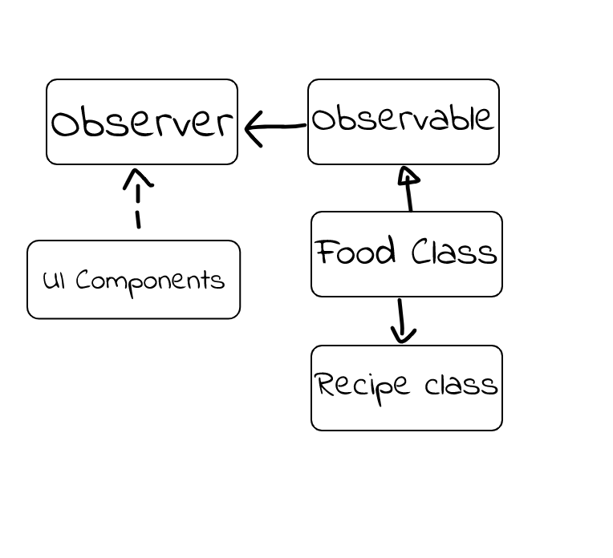

Rough Sequence Diagram

